3.85: The three relative velocities are:
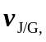 Juan relative to the ground. This velocity is due north and has magnitude 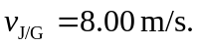
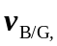 the ball relative to the ground. This vector is 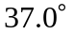 east of north and has magnitude 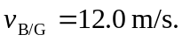
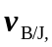 the ball relative to Juan. We are asked to find the magnitude and direction of this vector.
The relative velocity addition equation is 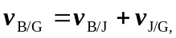 so 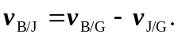
Take 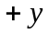 to be north and 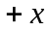 to be east.
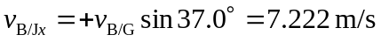
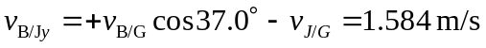
These two components give 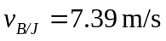 at 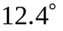 north of east.

